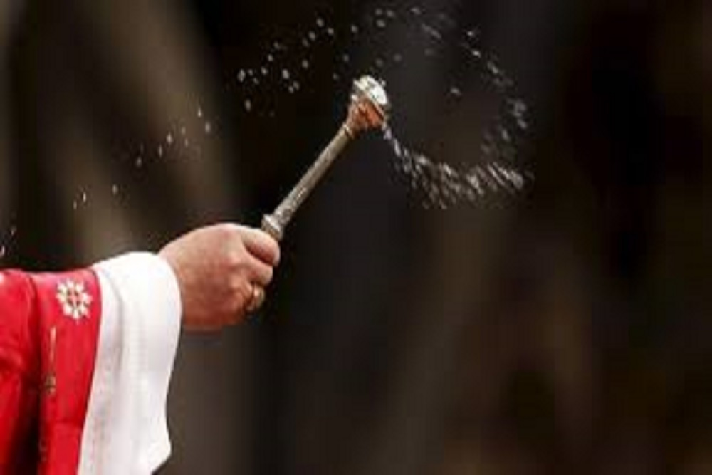

WHAT DOES HOLY WATER SYMBOLIZE

In its ritual sense it means baptismal water. In its Biblical sense it denotes God as the fountain-head or source of life. In its Christian sense it symbolizes the Holy Spirit'
What is the power of holy water?

Catholic saints have written about the power of holy water as a force that repels evil. Saint Teresa of Avila (1515-1582), a Doctor of the Church who reported visions of Jesus and Mary, believed fervently in the power of holy water and stated that she used it with success to repel evil and temptations.

What happens when you bless yourself with holy water?

Holy Water Is Powerful
The rite of blessing that a priest says over to make it holy contains prayers of exorcism. It can banish demons, heal the sick, and send unwarranted grace upon us—yet most of the time we cross ourselves with this water without even thinking about how holy it really is.

I would like to mention now a few ways the Church encourages us to use holy water.
Primary place goes to the use of holy water when we enter into a Catholic church. We dip our hands into the water and make the Sign of the Cross saying the words of our baptism: “In the name of the Father and of the Son and of the Holy Spirit. Amen.” This little action ought immediately to call to mind that we once entered not a building made with hands, but we entered into the Church, the assembly of believers who attend the eternal banquet of the Lamb.
Second place goes to sprinkling our homes and especially our bedrooms with holy water. Furthermore, smudging holy water on one’s children is an age-old practice as we see in many Latin and other cultures of the world.
Holy water is better than mosquito repellent; this stuff repels the devil. It repels the devil because the more we draw close to God in the sacraments and with the use of this sacramental, the less power the evil one has over us.
Holy water can also be used to sprinkle one’s own property, whom we promised to obey when we were baptized.
Lastly, keep in mind that since holy water is a sacramental and thus holy, we must never pour this sacred water down the drain or sewer. It ought to be poured out on the ground if it has become too old for practical use. Keep in mind, too, that its spiritual powers never wear off.

