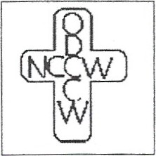
Orlando Diocesan Council of Catholic Women

National Council of Catholic Women
Date: September 9, 2023
Affiliation Councils of Catholic Women
From: Esteemed Life Member Committee
Nomination for Esteemed Life Member
The Esteemed Life Member Committee of the Orlando Diocesan Council of Catholic Women is excited to provide you with the guidelines for the Esteemed Life Member Award to be presented at the ODCCW Annual Convention.
This award is a way to honor those women who have been active and faithful to our organization. If you have someone in your organization who meets the qualifications, please use the attached form to submit your nomination. She doesn’t have to have been an officer or chairman, but someone who has been involved in projects/ programs and otherwise been supportive of the Council’s goals and objectives.
A cover letter must be provided with the submission and shall be the ONLY place the nominee's name, affiliation, and parish are mentioned. Nominations from the affiliations must be forwarded, with a cover letter and the nominee's involvement, to the Esteemed Life Member Committee Chair by March 23, 2024. You may email it or send it by regular mail. Feel free to use more than one page for information on nominee.
Send forms to: Karen Hill
3310 Honeysuckle Lane
Belle Isle, FL 32812
karenkh@cfl.rr.com

Commettee Members: Virginia Hagan
Sue Miller

